**We Rate Dogs Insights**

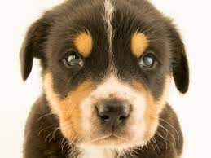

These are insights on the We Rate Dogs Twitter account where humorous comments about dogs are posted.

**Insights:**

* Number of images that occurred for each tweet confident image prediction
* The most common stages of dogs
* What are the top names of dogs?
* The increase or decrease of retweets and liking as the years pass

1. **Number of images that occurred for each tweet confident image prediction**

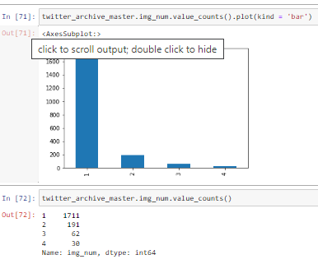It is observed that the greatest number of pictures posted to make predictions on the type of Dog it is mostly one (1).

So, it means a single picture was able to model what stage of the dog it is.

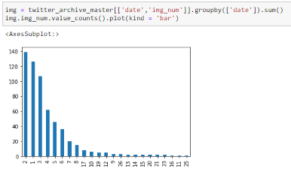**Most number of pictures posted per day**

For each day, the greatest number of pictures posted is 2

1. **The most common stages of dogs**

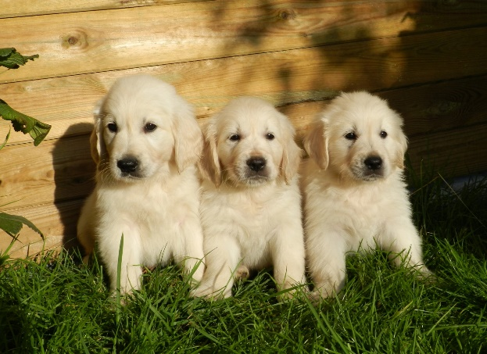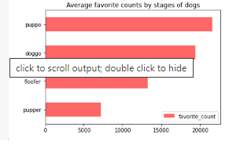The most loved stage of dogs based on the favorite count is puppo. People love the cuteness of puppies.

While the most common dog posted is the pupper based on the number of occurrence

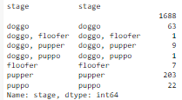

1. **What are the top names of dogs?**

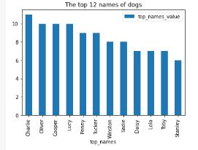The top 12 names of dogs are shown.

And Charlie is the most common name

1. **The increase or decrease of retweets and liking as the years pass**

Note: There are more than a tweet per day

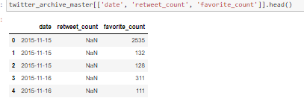

Hence the need to deal with them per day – grouping

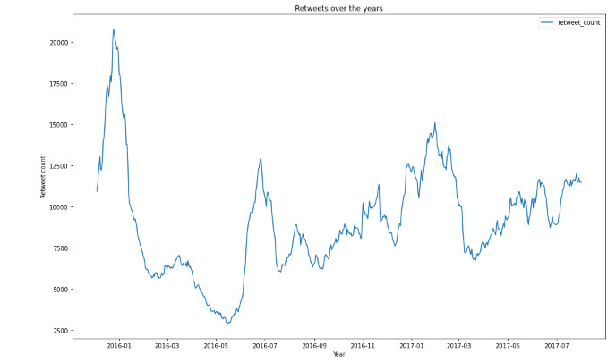There’s a decrease in retweets over the years. Though there’re times it increases, but unlike when it started.

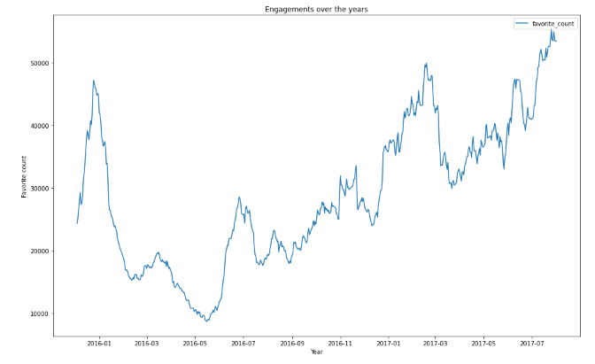

Unlike the retweets, there are more ‘likes’ on the posts. A progressive increase over the years.

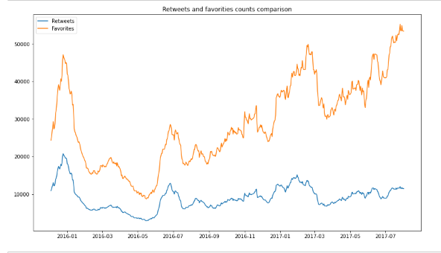Plotting both, we have:

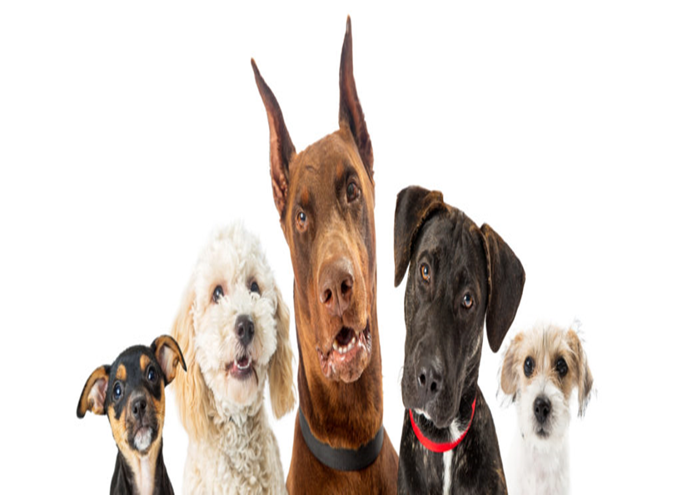

Clearly evident of the increase in favorite_count and a drop in retweets_count.

THANK YOU